Erik Nunez

12/6/17 (Requested extension by Email)

ECE 446

Project 2

Part A

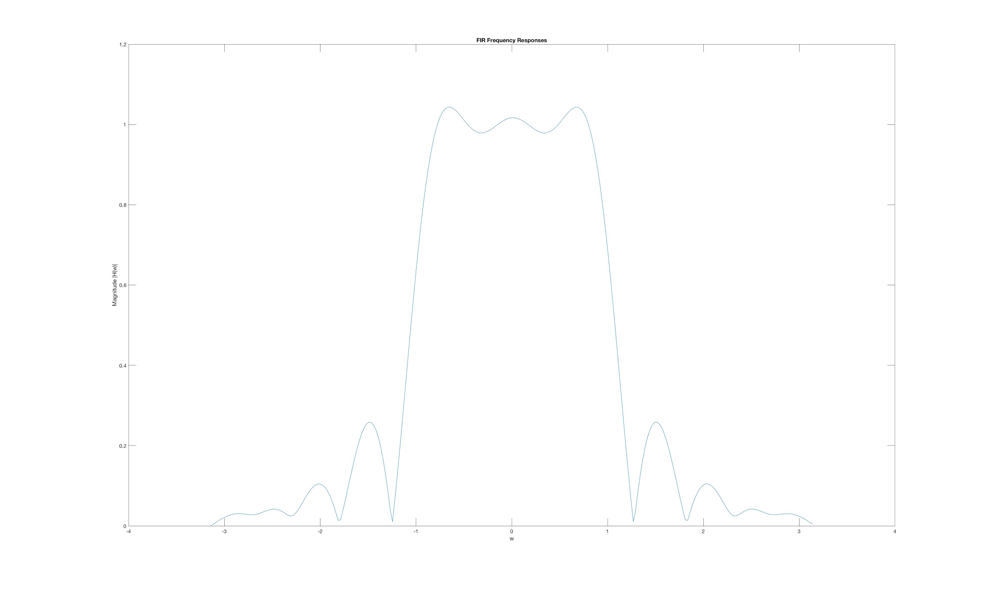

Part B

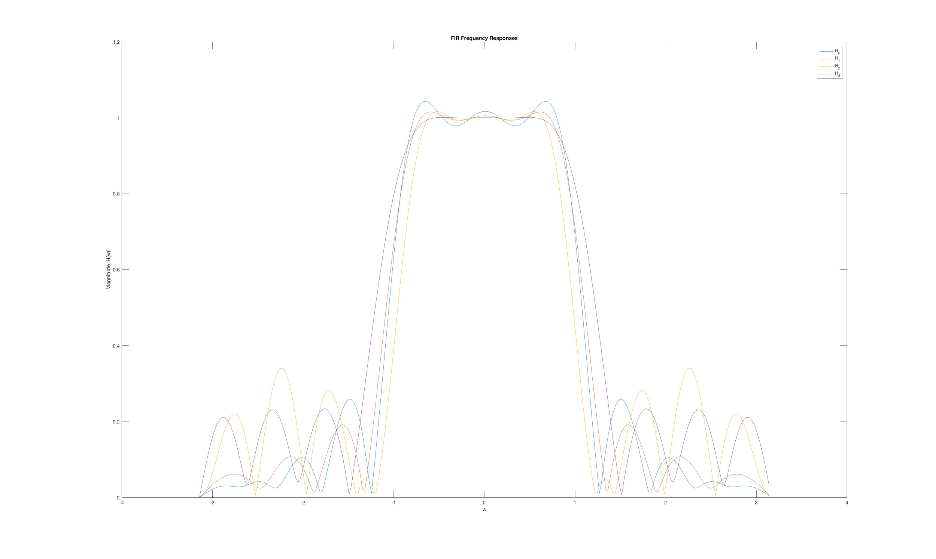

What conclusions can you draw from these results ?

A higher δ results in less ripples for the pass band.

Part C

Window Functions

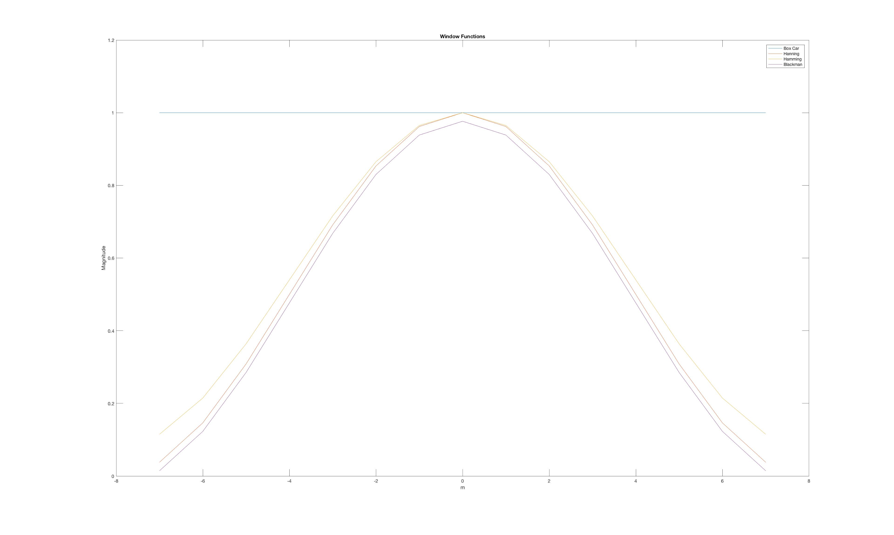

Frequency Response

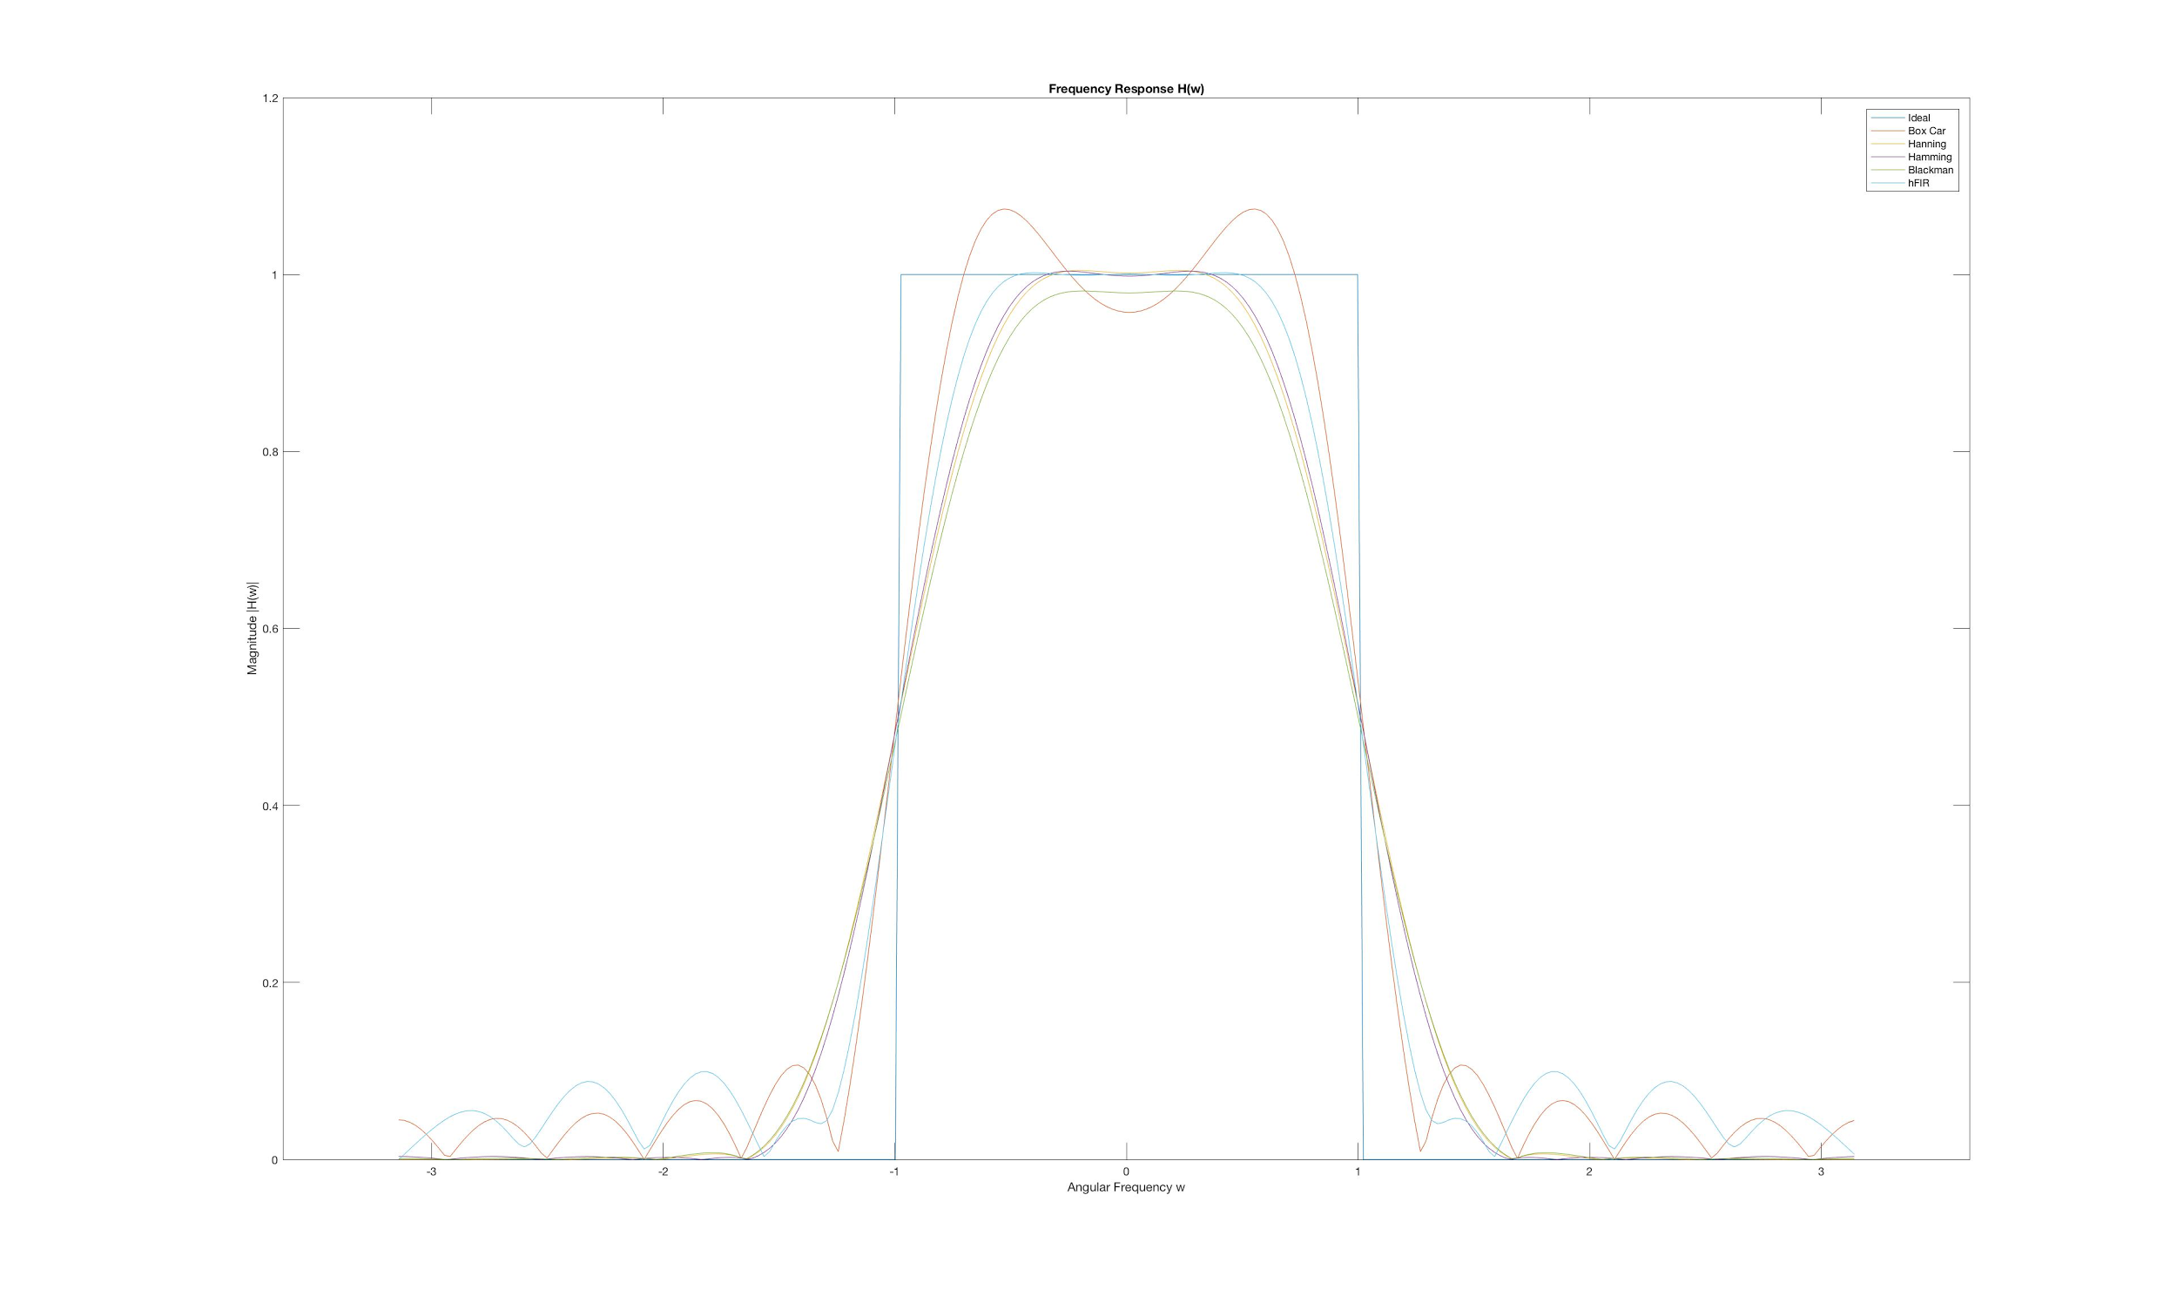

How do the frequency responses obtained from the four windows compare with each other, and also with the FIR filter ?

I believe that the Hamming and Blackman windows provided the closest frequency responses for the ideal filter as they had the least ripples in both the pass and stop bands. hFIR has the closest to ideal filter if the ripples in the stop band weren’t taken into account.